The Sixth Sunday
of Easter

May 9, 2021

10:00 am

1101 Bay Ridge Avenue
Annapolis, Maryland 21403
www.stlukeseastport.org

The Liturgy of the Word

Prelude Dr. Ildar Khannanov

Opening Hymn Now the green blade riseth H-204

1. Now the green blade riseth from the buried grain,
Wheat that in dark earth many days has lain;
Love lives again, that with the dead has been:
Love is come again like wheat that springeth green.

2. In the grave they laid him, Love whom hate had slain,
Thinking that never he would wake again,
Laid in the earth like grain that sleeps unseen:
Love is come again like wheat that springeth green.

3. Forth he came at Easter, like the risen grain,
He that for three days in the grave had lain;
Quick from the dead my risen Lord is seen:
Love is come again like wheat that springeth green.

4. When our hearts are wintry, grieving, or in pain,
Thy touch can call us back to life again,
Fields of our hearts that dead and bare have been:
Love is come again like wheat that springeth green.

Celebrant Alleluia! Christ is risen.
People The Lord is risen indeed. Alleluia!

Celebrant Almighty God, to you all hearts are open, all desires known, and from you no secrets are hid: Cleanse the thoughts of our hearts by the inspiration of your Holy Spirit, that we may perfectly love you, and worthily magnify your holy Name; through Christ our Lord.
People Amen.

Gloria S-280

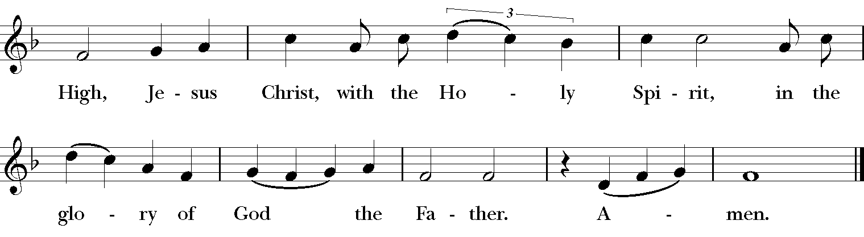

Setting: Robert Powell (b. 1932)

The Collect of the Day

Celebrant The Lord be with you.
People And also with you.

Celebrant Let us pray.

O God, you have prepared for those who love you such good things as surpass our understanding: Pour into our hearts such love towards you, that we, loving you in all things and above all things, may obtain your promises, which exceed all that we can desire; through Jesus Christ our Lord, who lives and reigns with you and the Holy Spirit, one God, for ever and ever.
People Amen.

First Reading Acts 10:44-48

Reader A Reading from the Acts of the Apostles.

While Peter was still speaking, the Holy Spirit fell upon all who heard the word. The circumcised believers who had come with Peter were astounded that the gift of the Holy Spirit had been poured out even on the Gentiles, for they heard them speaking in tongues and extolling God. Then Peter said, "Can anyone withhold the water for baptizing these people who have received the Holy Spirit just as we have?" So he ordered them to be baptized in the name of Jesus Christ. Then they invited him to stay for several days.
Reader The Word of the Lord.
People Thanks be to God.

Psalm 98 St. Helena Breviary
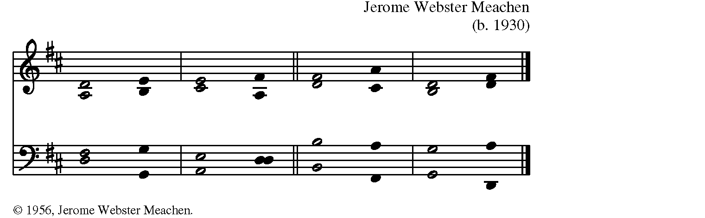

1 Sing a new song to God, *
who has done marvelous things.
2 With your right hand, O God, and your holy arm, *
you have won for yourself the victory.
3 You have made known your victory; *
your righteousness have you openly shown in the sight of the nations.
4 You remember your mercy and faithfulness to the house of Israel, *
and all the ends of the earth have seen the victory of our God.
5 Shout with joy to God, all you lands; *
lift up your voice, rejoice, and sing.
6 Sing to God with the harp, *
with the harp and the voice of song.
7 With trumpets and the sound of the horn, *
shout with joy before our God who reigns in majesty.
8 Let the sea make a noise and all that is in it, *
the lands and those who dwell therein.
9 Let the rivers clap their hands, *
and let the hills ring out with joy before God, who will come to judge the earth;
10 God shall judge the world in righteousness *
and the peoples with equity.

Second Reading 1 John 5:1-6
Reader A reading from the First Letter of John.

Everyone who believes that Jesus is the Christ has been born of God, and everyone who loves the parent loves the child. By this we know that we love the children of God, when we love God and obey his commandments. For the love of God is this, that we obey his commandments. And his commandments are not burdensome, for whatever is born of God conquers the world. And this is the victory that conquers the world, our faith. Who is it that conquers the world but the one who believes that Jesus is the Son of God? This is the one who came by water and blood, Jesus Christ, not with the water only but with the water and the blood. And the Spirit is the one that testifies, for the Spirit is the truth.

Reader The Word of the Lord.
People Thanks be to God.

Sequence Hymn One Bread, One Body L-151

One bread, one body,
one Lord of all,
one cup of blessing which we bless.
And we, though many,
throughout the earth,
we are one body in this one Lord.

1. Gentile or Jew,
servant or free,
woman or man, no more. Refrain

2. Many the gifts,
many the works,
one in the Lord of all. Refrain

3. Grain for the fields,
scattered and grown,
gathered to one, for all. Refrain

The Gospel John 15:9-17

Minister The Holy Gospel of our Lord Jesus Christ according to John.
People Glory to you, Lord Christ.

Jesus said to his disciples, “As the Father has loved me, so I have loved you; abide in my love. If you keep my commandments, you will abide in my love, just as I have kept my Father’s commandments and abide in his love. I have said these things to you so that my joy may be in you, and that your joy may be complete. “This is my commandment, that you love one another as I have loved you. No one has greater love than this, to lay down one’s life for one’s friends. You are my friends if you do what I command you. I do not call you servants any longer, because the servant does not know what the master is doing; but I have called you friends, because I have made known to you everything that I have heard from my Father. You did not choose me but I chose you. And I appointed you to go and bear fruit, fruit that will last, so that the Father will give you whatever you ask him in my name. I am giving you these commands so that you may love one another.”

Minister The Gospel of the Lord.
People Praise to you, Lord Christ.

Sermon The Rev. Diana Carroll
After the sermon, silence may be kept.

The Nicene Creed A New Zealand Prayer Book, pg. 410

We believe in one God, the Father, the Almighty, maker of heaven and earth, of all that is, seen and unseen. We believe in one Lord, Jesus Christ, the only Son of God, eternally begotten of the Father, God from God, Light from Light, true God from true God, begotten, not made, of one Being with the Father; through him all things were made. For us and for our salvation he came down from heaven: was incarnate of the Holy Spirit and the Virgin Mary and became fully human. For our sake he was crucified under Pontius Pilate; he suffered death and was buried. On the third day he rose again in accordance with the Scriptures; he ascended into heaven and is seated at the right hand of the Father. He will come again in glory to judge the living and the dead, and his kingdom will have no end. We believe in the Holy Spirit, the Lord, the giver of life, who proceeds from the Father and the Son, who in unity with the Father and the Son is worshiped and glorified, and has spoken through the Prophets. We believe in one holy catholic and apostolic Church. We acknowledge one baptism for the forgiveness of sins. We look for the resurrection of the dead, and the life of the world to come. Amen.

The Prayers of the People: Form III BCP pg. 387

Leader O God, we pray for your holy Catholic Church;
People That we all may be one.

Leader Grant that every member of the Church may truly and humbly serve you;
People That your Name may be glorified by all people.

Leader We pray for all bishops, priests, and deacons,
People That they may be faithful ministers of your Word and Sacraments.

Leader We pray for all who govern and hold authority in the nations of the world,
People That there may be justice and peace on the earth.

Leader Give us grace to do your will in all that we undertake;
People That our works may find favor in your sight.

Leader Have compassion on those who suffer from any grief or trouble;
People That they may be delivered from their distress.

Leader Give to the departed eternal rest;
People Let light perpetual shine upon them.

Leader We praise you for your saints who have entered into joy;
People May we also come to share in your heavenly kingdom.

Leader Let us pray for our own needs and those of others.

In the Anglican Communion, we pray for ___________________.

In the Diocese of Maryland, we pray for____________________.

In our own community, we pray for those on our parish prayer list, especially _________________, and for those we now name, aloud or in our hearts.

The people may add their own petitions verbally, using the chat, or in the comments.

Celebrant On this Mother's Day, we give thanks to God for the divine gift of motherhood in all its diverse forms. Let us pray for all the mothers among us today; for our own mothers, those living and those who have passed away; for the mothers who loved us and for those who fell short of loving us fully; for all who hope to be mothers someday and for those whose hope to have children has been frustrated; for all mothers who have lost children; for all people of any gender who have been our substitute mothers and we who have done so for those in need; and for the earth that bore us and provides us sustenance. We pray this all in the name of God, our great and loving Mother.
People Amen.

The Peace

Celebrant La paz del Señor sea siempre con ustedes.
The peace of the Lord be always with you
People And also with you. or Y con tu espíritu.

Parish Notices

The Holy Communion

Offertory Sentence

Celebrant Let us with gladness present the offerings and oblations of our life and labor to the Lord.

Offertory Anthem If Ye Love Me (Thomas Tallis)

Doxology Praise God, from whom all blessings flow H-380 V3

Praise God, from whom all blessings flow;
Praise Him, all creatures here below;
Praise Him above, ye heav'nly host;
Praise Father, Son, and Holy Ghost. Amen.

The Great Thanksgiving Eucharistic Prayer A*, BCP pg. 361

Celebrant The Lord be with you.
People And also with you.
Celebrant Lift up your hearts.
People We lift them to the Lord.
Celebrant Let us give thanks to the Lord our God.
People It is right to give God thanks and praise.

Celebrant It is right, and a good and joyful thing, always and everywhere to give thanks to you, Almighty God, Creator of heaven and earth, but chiefly are we bound to praise you for the glorious resurrection of your Son Jesus Christ our Lord; for he is the true Paschal Lamb, who was sacrificed for us, and has taken away the sin of the world. By his death he has destroyed death, and by his rising to life again he has won for us everlasting life.

Therefore we praise you, joining our voices with Angels and Archangels and with all the company of heaven, who for ever sing this hymn to proclaim the glory of your Name:

Sanctus S-125
+
+
+
Setting: From A Community Mass; Richard Proulx (b. 1937)

Celebrant Holy and gracious God: In your infinite love you made us for yourself; and, when we had fallen into sin and become subject to evil and death, you, in your mercy, sent Jesus Christ, your only and eternal Son, to share our human nature, to live and die as one of us, to reconcile us to you, the God and maker of all. Jesus stretched out his arms upon the cross, and offered himself in obedience to your will, a perfect sacrifice for the whole world.

On the night he was handed over to suffering and death, our Savior Jesus Christ took bread; and when he had given thanks to you, he broke it, and gave it to his disciples, and said, “Take, eat: This is my Body, which is given for you. Do this for the remembrance of me.” +

After supper Jesus took the cup of wine; and when he had given thanks, he gave it to them, and said, “Drink this, all of you: This is my Blood of the new Covenant, which is shed for you and for many for the forgiveness of sins. Whenever you drink it, do this for the remembrance of me.” +

Therefore we proclaim the mystery of faith:

Celebrant and People

Christ has died.
Christ is risen.
Christ will come again.

We celebrate the memorial of our redemption, Almighty God, in this sacrifice of praise and thanksgiving. Recalling Christ’s death, resurrection, and ascension, we offer you these gifts. Sanctify them by your Holy Spirit to be for your people the Body and Blood of your Son, the holy food and drink of new and unending life in Christ.

Sanctify us also that we may faithfully receive this holy Sacrament, and serve you in unity, constancy, and peace; and at the last day bring us with all your saints into the joy of your eternal kingdom.

All this we ask through Jesus Christ our Savior. By Christ, and with Christ, and in Christ, in the unity of the Holy Spirit all honor and glory is yours, Almighty God, now and for ever.

People AMEN.

The Lord's Prayer (Traditional)

Celebrant And now, as our Savior Christ has taught us, we are bold to say,

People Our Father, who art in heaven, hallowed be thy Name, thy kingdom come, thy will be done, on earth as it is in heaven. Give us this day our daily bread. And forgive us our trespasses, as we forgive those who trespass against us. And lead us not into temptation, but deliver us from evil. For thine is the kingdom, and the power, and the glory, for ever and ever. Amen.

The Breaking of the Bread

The Celebrant breaks the consecrated bread. A period of silence is kept.

Fraction Anthem S-171

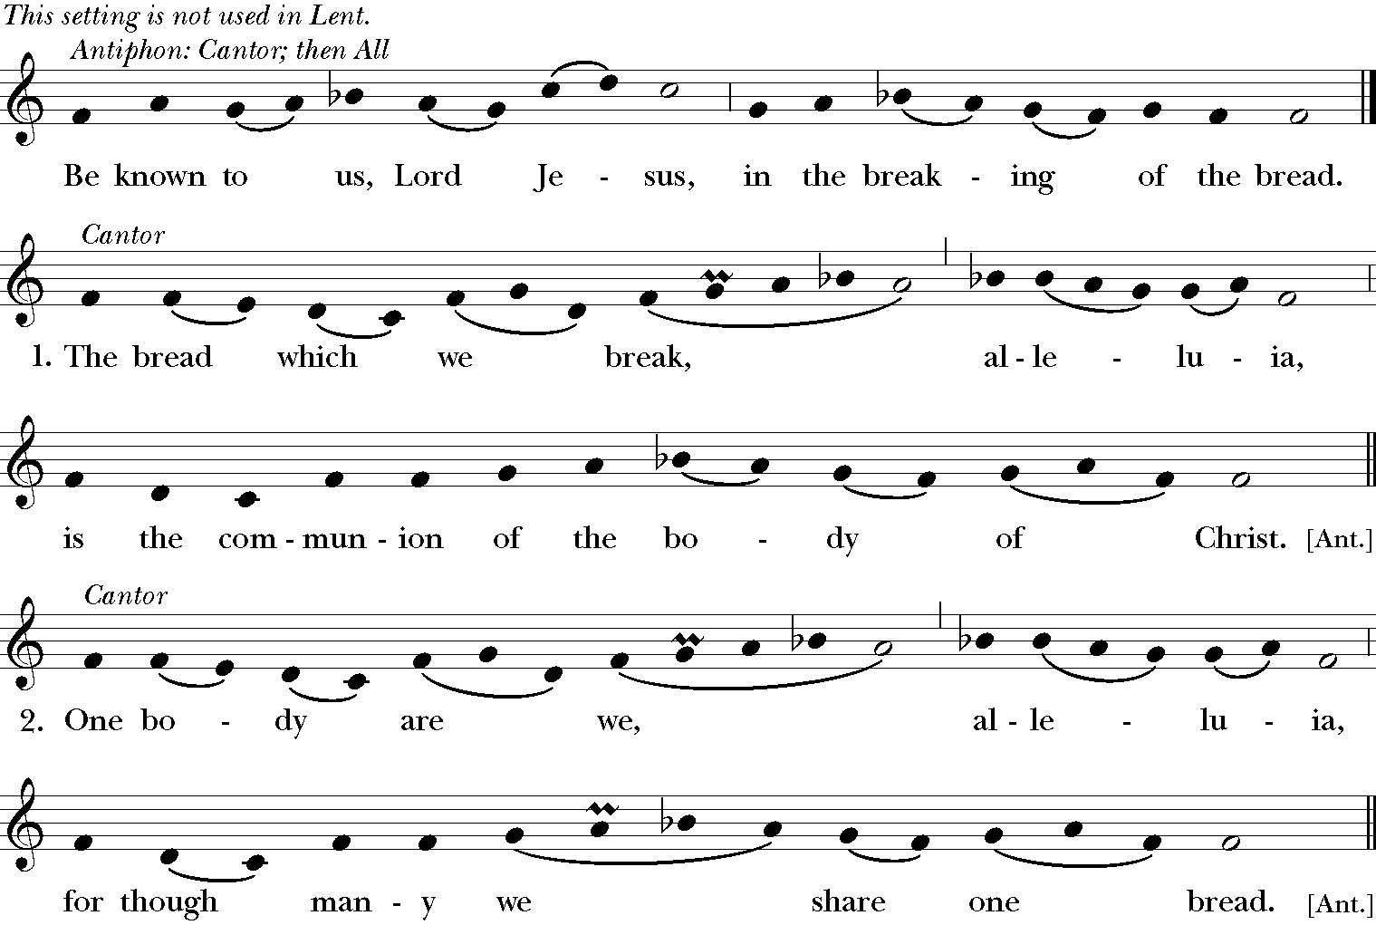

Mode 6 Melody; adapt. Mason Martens (1933-1991)

A Prayer for Spiritual Communion

People In union, O Lord, with your faithful people at every altar of your Church, where the Holy Eucharist is now being celebrated, we desire to offer to you praise and thanksgiving. We remember your death, Lord Christ; we proclaim your resurrection; we await your coming in glory. And since we cannot receive you today in the Sacrament of your Body and Blood, we beseech you to come spiritually into our hearts. Cleanse and strengthen us with your grace, Lord Jesus, and let us never be separated from you. May we live in you, and you in us, in this life and in the life to come. Amen.

Post-Communion Prayer EOW pg. 69

Celebrant Let us pray.

People God of abundance, you have fed us with the bread of life and cup of salvation; you have united us with Christ and one another; and you have made us one with all your people in heaven and on earth. Now send us forth in the power of your Spirit, that we may proclaim your redeeming love to the world and continue for ever in the risen life of Christ our Savior. Amen.

Blessing Chris Polhill, From “Fire and Bread” (compiled by Ruth Burgess)

Celebrant The power of the Creator, who brings life out of death, be in this place.
The risen Christ be your constant companion.
The healing embrace of the Holy Spirit encircle you, so that you see resurrection ever about you.

And the blessing of God, Creator, Christ, and Holy Spirit, be upon you and remain with you for ever.

People Amen.

Closing Hymn He’s Got the Whole World In His Hands L-217

1. He’s got the whole world in his hand. (4x)
2. He’s got you and me sister in his hand. (4x)
3. He’s got you and me brother in his hand. (4x)
4. He’s got the pretty little baby in his hand. (4x)
5. He’s got everybody here in his hand. (4x)

Dismissal

Celebrant ¡Aleluya, aleluya! Salgamos en nombre de Cristo.
Let us go forth in the name of Christ.
People Thanks be to God. Alleluia, Alleluia!
or Demos gracias a Dios. ¡Aleluya, aleluya!

Postlude Dr. Ildar Khannanov

The texts in this service are from The Book of Common Prayer 1979 (BCP), Enriching our Worship (EOW), and El Libro de Oración Común. Hymns and service music are from The Hymnal 1982 and Lift Every Voice and Sing II. Used by permission. OneLicense.net #A-722440.

*This service makes use of an alternative form of Eucharistic Prayer A, as approved for trial use by General Convention in Resolution 2018-D078.

