The Third Sunday in Lent

March 7, 2021

10:00 am

1101 Bay Ridge Avenue
Annapolis, Maryland 21403
www.stlukeseastport.org

Liturgy of the Word

The season of Lent is a time that invites self-reflection and a renewal of our relationship with God. This year, we are especially focusing on the pervasiveness of racial injustice in our world and in our lives. Together, we are called to repent, work for reconciliation, and commit ourselves to building the beloved community of God.

Prelude

Opening Hymn God the sculptor of the mountains (Thornburg/Husburg)

1. God the sculptor of the mountains,
God the miller of the sand,
God the jeweler of the heavens,
God the potter of the land:
You are womb of all creation,
We are formless; shape us now.

2. God the nuisance to the Pharaoh,
God the cleaver of the sea,
God the pillar of the darkness,
God the beacon of the free:
You are gate of all deliverance,
We are sightless; lead us now.

3. God the dresser of the vineyard,
God the planter of the wheat,
God the reaper of the harvest,
God the source of all we eat:
you are host at every table,
we are hungry; feed us now.

4. God the unexpected infant,
God the calm, determined youth,
God the table-turning prophet,
God the resurrected Truth:
You are present every moment,
We are searching; meet us now.

Celebrant Blessed be the God of our salvation:
People Who bears our burdens and forgives our sins.

Celebrant Since we have a great high priest who has passed through the heavens, Jesus, the Son of God, let us with confidence draw near to the throne of grace, that we may receive mercy and find grace to help in time of need.
Hebrews 4:14,16

Confession of Sin Standing Commission on Liturgy and Music

Celebrant Let us confess our sins against God and one another.
Silence is kept.

People Almighty God, Source of all that is, Giver of every good gift: You create all people in your image and call us to love one another as you love us. We confess that we have failed to honor you in the great diversity of the human family. We have desired to live in freedom, while building walls between ourselves and others. We have longed to be known and accepted for who we are, while making judgements of others based on the color of skin, or the shape of features, or the varieties of human experience. We have tried to love our neighbors individually while yet benefitting from systems that hold those same neighbors in oppression. Forgive us, Holy God. Give us eyes to see you as you are revealed in all people. Strengthen us for the work of reconciliation rooted in love. Restore us in your image, to be beloved community, united in our diversity, even as you are one with Christ and the Spirit, Holy and undivided Trinity, now and for ever. Amen.
Celebrant Almighty God have mercy on you, forgive you all your sins through the grace of Jesus Christ, strengthen you in all goodness, and by the power of the Holy Spirit keep you in eternal life.
People Amen.

Kyrie Eleison S-96

Setting: From Deutsche Messe, Franz Peter Schubert (1797-1828); arr. Richard Proulx (b. 1937)

The Collect of the Day

Celebrant The Lord be with you.
People And also with you.

Celebrant Let us pray.
Almighty God, you know that we have no power in ourselves to help ourselves: Keep us both outwardly in our bodies and inwardly in our souls, that we may be defended from all adversities which may happen to the body, and from all evil thoughts which may assault and hurt the soul; through Jesus Christ our Lord, who lives and reigns with you and the Holy Spirit, one God, for ever and ever.
People Amen.

First Reading Exodus 20:1-17

Reader A Reading from the Book of Exodus.

Then God spoke all these words: I am the Lord your God, who brought you out of the land of Egypt, out of the house of slavery; you shall have no other gods before me. You shall not make for yourself an idol, whether in the form of anything that is in heaven above, or that is on the earth beneath, or that is in the water under the earth. You shall not bow down to them or worship them; for I the Lord your God am a jealous God, punishing children for the iniquity of parents, to the third and the fourth generation of those who reject me, but showing steadfast love to the thousandth generation of those who love me and keep my commandments. You shall not make wrongful use of the name of the Lord your God, for the Lord will not acquit anyone who misuses his name. Remember the sabbath day, and keep it holy. For six days you shall labor and do all your work. But the seventh day is a sabbath to the Lord your God; you shall not do any work—you, your son or your daughter, your male or female slave, your livestock, or the alien resident in your towns. For in six days the Lord made heaven and earth, the sea, and all that is in them, but rested the seventh day; therefore the Lord blessed the sabbath day and consecrated it. Honor your father and your mother, so that your days may be long in the land that the Lord your God is giving you. You shall not murder. You shall not commit adultery. You shall not steal. You shall not bear false witness against your neighbor. You shall not covet your neighbor’s house; you shall not covet your neighbor’s wife, or male or female slave, or ox, or donkey, or anything that belongs to your neighbor.

Reader The Word of the Lord.
People Thanks be to God.

Psalm 19 St. Helena Breviary

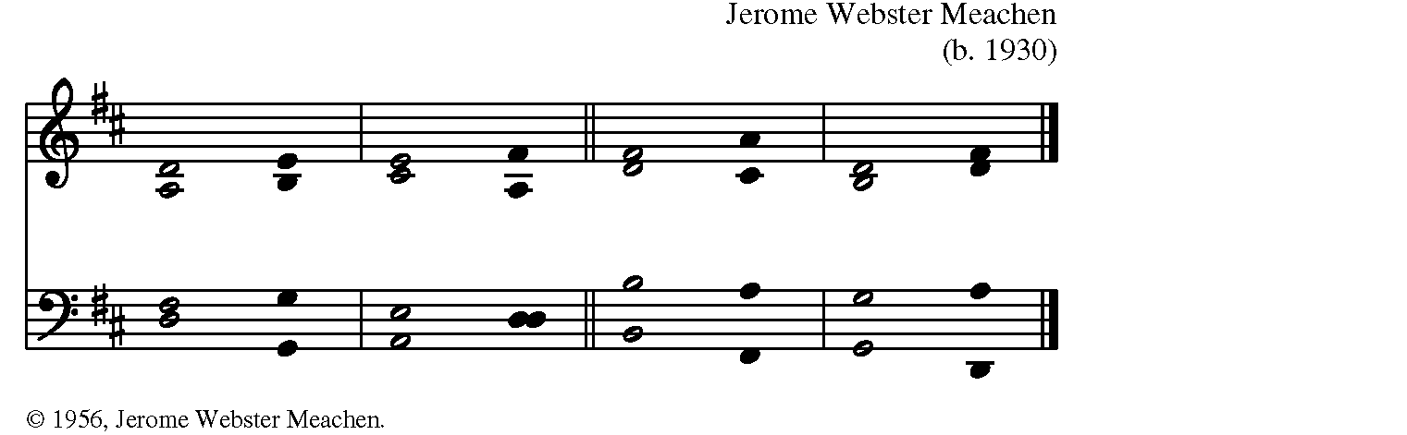

Jerome Webster Meachen

1 The heavens declare your glory, O God, *
and the firmament shows your handiwork.
2 One day tells its tale to another, *
and one night imparts knowledge to another.

3 Although they have no words or language, *
and their voices are not heard,
4 Their sound has gone out into all lands, *
and their message to the ends of the world.

5 In the deep you have set a pavilion for the sun; *
it comes forth like a bridegroom out of his chamber;
it rejoices like a champion to run its course.
6 It goes forth from the uttermost edge of the heavens
and runs about to the end of it again; *
nothing is hidden from its burning heat.

7 Your law, O God, is perfect and revives the soul; *
your testimony is sure and gives wisdom to the innocent.
8 Your statutes are just and rejoice the heart; *
your commandment is clear and gives light to the eyes.

9 The fear of you is clean and endures for ever; *
your judgments are true and righteous altogether.
10 More to be desired are they than gold,
more than much fine gold, *
sweeter far than honey, than honey in the comb.

11 By them also is your servant enlightened, *
and in keeping them there is great reward.
12 Who can tell how often one offends? *
Cleanse me from my secret faults.

13 Above all, keep your servant from presumptuous sins;
let them not get dominion over me; *
then shall I be whole and sound, and innocent of a great offense.
14 Let the words of my mouth and the meditation of my heart
be acceptable in your sight, *
O God, my strength and my redeemer.

Contemporary Epistle Helen Leitch

During Lent, in place of the second scripture reading, members of our
congregation will share personal stories of growth in their understanding
of racism, privilege, and systemic racial inequity.

Sequence Hymn Lord, who throughout these forty days H-142

1. Lord, who throughout these forty days
For us didst fast and pray,
Teach us with thee to mourn our sins
And close by thee to stay.

2. As thou with Satan didst contend
And didst the victory win,
O give us strength in thee to fight,
In thee to conquer sin.

3. As thou didst hunger bear and thirst,
So teach us, gracious Lord,
To die to self, and chiefly live
By thy most holy word.

4. And through these days of penitence,
And through thy Passiontide,
yea, evermore, in life and death,
Jesus! with us abide.

5. Abide with us, that so, this life
Of suffering overpast,
An Easter of unending joy
We may attain at last!

The Gospel John 2:13-22

Celebrant The Holy Gospel of our Lord Jesus Christ according to John.
People Glory to you, Lord Christ.

The Passover of the Jews was near, and Jesus went up to Jerusalem. In the temple he found people selling cattle, sheep, and doves, and the money changers seated at their tables. Making a whip of cords, he drove all of them out of the temple, both the sheep and the cattle. He also poured out the coins of the money changers and overturned their tables. He told those who were selling the doves, “Take these things out of here! Stop making my Father’s house a marketplace!” His disciples remembered that it was written, “Zeal for your house will consume me.” The religious leaders then said to him, “What sign can you show us for doing this?” Jesus answered them, “Destroy this temple, and in three days I will raise it up.” The religious leaders then said, “This temple has been under construction for forty-six years, and will you raise it up in three days?” But he was speaking of the temple of his body. After he was raised from the dead, his disciples remembered that he had said this; and they believed the scripture and the word that Jesus had spoken.

Celebrant The Gospel of the Lord.
People Praise to you, Lord Christ.

Sermon The Rev. Diana Carroll

After the sermon, silence may be kept.

The Nicene Creed A New Zealand Prayer Book, pg. 410

We believe in one God, the Father, the Almighty, maker of heaven and earth, of all that is, seen and unseen. We believe in one Lord, Jesus Christ, the only Son of God, eternally begotten of the Father, God from God, Light from Light, true God from true God, begotten, not made, of one Being with the Father; through him all things were made. For us and for our salvation he came down from heaven: was incarnate of the Holy Spirit and the Virgin Mary and became fully human. For our sake he was crucified under Pontius Pilate; he suffered death and was buried. On the third day he rose again in accordance with the Scriptures; he ascended into heaven and is seated at the right hand of the Father. He will come again in glory to judge the living and the dead, and his kingdom will have no end. We believe in the Holy Spirit, the Lord, the giver of life, who proceeds from the Father and the Son, who in unity with the Father and the Son is worshiped and glorified, and has spoken through the Prophets. We believe in one holy catholic and apostolic Church. We acknowledge one baptism for the forgiveness of sins. We look for the resurrection of the dead, and the life of the world to come. Amen.

Prayers of the People Standing Commission on Liturgy and Music

Celebrant Let us pray for the Church and for the world.

Leader God of love, we pray for your church: For Michael, our Presiding Bishop; Eugene and Bob, our bishops; for all lay and ordained ministers; and for all who seek you in the community of the faithful. Equip us with compassion and love, to carry out your work of reconciliation in the world.
God of love,
People Hear our prayers for the church.

Leader God of freedom, we pray for our nation, and all the nations of the world: For peace and unity across barriers of language, color, and creed; for elected and appointed leaders, that they would serve the common good. Inspire all people with courage to speak out against hatred, to actively resist evil. Unite the human family in bonds of love.
God of freedom,
People Hear our prayers for the world.

Leader God of justice, we pray for the earth, your creation entrusted to our care: For the animals and birds, the mountains and oceans, and all parts of your creation that have no voice of their own. Stir up in us a thirst for justice that protects the earth and all its resources, that we may leave to our children’s children the legacy of beauty and abundance that you have given us.
God of justice,
People Hear our prayers for the earth.

Leader God of peace, we pray for this community: For our local leaders; for our schools and businesses; for our neighborhoods and workplaces. Kindle in every heart a desire for equality, respect, and opportunity for all. Give us courage to strive for justice and peace among all people, beginning here at home.
God of peace,
People Hear our prayers for this community.

Leader God of mercy, we pray for all in any kind of need or trouble: For those whose lives are closely linked with ours, and those connected to us as part of the human family. For refugees and prisoners; for the sick and suffering, the lonely and despairing; for those facing violence; for all held down by prejudice or injustice. Awaken in us compassion and humility of spirit, as we seek and serve Christ in all persons.
God of mercy,
People Hear our prayers for all who are in need.

Leader God of grace, we pray for those who have died [especially _________]: For the faithful in every generation who have worked for justice; for prophets who called us to racial reconciliation; for martyrs who died because of hatred; and for all the communion of saints. Make us faithful to your call to proclaim your Good News, by word and example, and bring us at last into the glorious company of the saints in light.
God of grace,
People Hear our prayers for those who have died.

Celebrant O God, you made us in your own image and redeemed us through Jesus your Son: Look with compassion on the whole human family; take away the arrogance and hatred which infect our hearts; break down the walls that separate us; unite us in bonds of love; and work through our struggle and confusion to accomplish your purposes on earth; that, in your good time, all nations and races may serve you in harmony around your heavenly throne; through Jesus Christ our Lord.
People Amen.

The Peace

Celebrant La paz del Señor sea siempre con ustedes.
The peace of the Lord be always with you
People And also with you. or Y con tu espíritu.

Parish Notices

The Holy Communion

Offertory Sentence

Celebrant I appeal to you, beloved, by the mercies of God, to present yourselves as a living sacrifice, holy and acceptable to God, which is your spiritual worship.

Offertory Anthem Give Me a Clean Heart (Margaret J. Douroux)

Offertory Hymn Beloved, let us love one another (Arthur Foote)

Beloved, Beloved, let us love one another,
for love is of God. For love is of God.
Beloved, Beloved, let us love one another, for God is love.

The Great Thanksgiving Eucharistic Prayer 1, EOW pg. 57

Celebrant The Lord be with you.
People And also with you.
Celebrant Lift up your hearts.
People We lift them to the Lord.
Celebrant Let us give thanks to the Lord our God.
People It is right to give God thanks and praise.

Celebrant It is truly right, and good and joyful, to give you thanks, all-holy God, source of life and fountain of mercy. You bid your faithful people cleanse their hearts, and prepare with joy for the Pascal feast; that, fervent in prayer and in works of mercy, and renewed by your Word and Sacraments, they may come to the fullness of grace which you have prepared for those who love you.

Therefore, joining with Angels and Archangels and with the faithful of every generation, we lift our voices with all creation as we sing:

Sanctus S-130
+
+
+
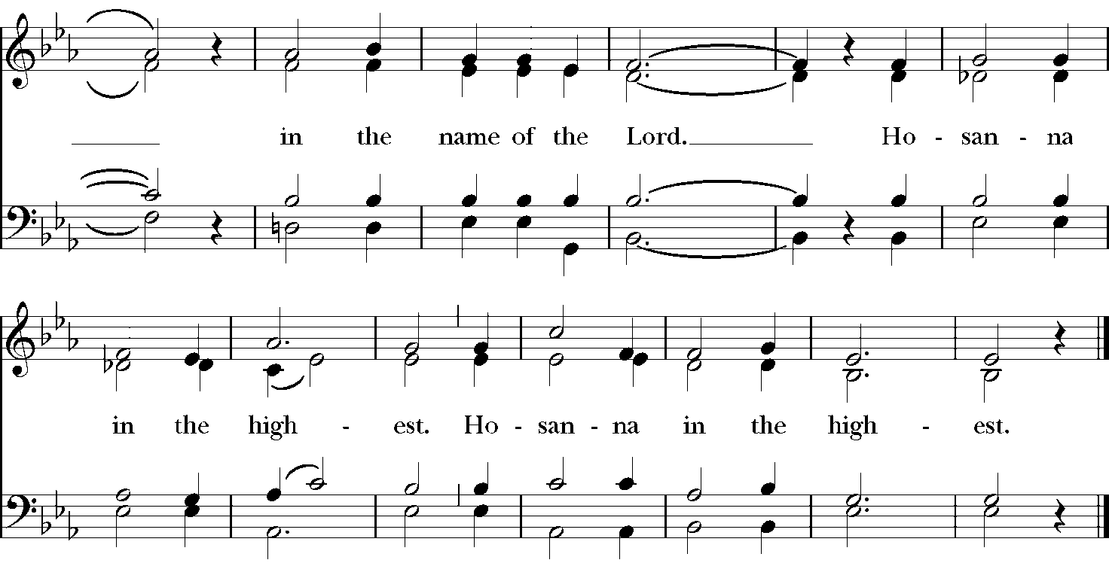

Setting: From Deutsche Messe, Franz Peter Schubert (1797-1828); arr. Richard Proulx (b. 1937)

Celebrant Blessed are you, gracious God, creator of the universe and giver of life. You formed us in your own image and called us to dwell in your infinite love. You gave the world into our care that we might be your faithful stewards and show forth your bountiful grace.

But we failed to honor your image in one another and in ourselves; we would not see your goodness in the world around us; and so we violated your creation, abused one another, and rejected your love. Yet you never ceased to care for us, and prepared the way of salvation for all people. Through Abraham and Sarah you called us into covenant with you. You delivered us from slavery, sustained us in the wilderness, and raised up prophets to renew your promise of salvation.
Then, in the fullness of time, you sent your eternal Word, made mortal flesh in Jesus. Born into the human family, and dwelling among us, he revealed your glory. Giving himself freely to death on the cross, he triumphed over evil, opening the way of freedom and life.

On the night before he died for us, our Savior Jesus Christ took bread, and when he had given thanks to you, he broke it, and gave it to his friends, and said: “Take, eat: This is my Body which is given for you. Do this for the remembrance of me.” +

As supper was ending, Jesus took the cup of wine, and when he had given thanks, he gave it to them, and said: “Drink this, all of you: This is my Blood of the new Covenant, which is poured out for you and for all for the forgiveness of sins. Whenever you drink it, do this for the remembrance of me.” +

Therefore we proclaim the mystery of faith:

Celebrant and People
Christ has died.
Christ is risen.
Christ will come again.

The Celebrant continues

Remembering his death and resurrection, we now present to you from your creation this bread and this wine. By your Holy Spirit may they be for us the Body and Blood of our Savior Jesus Christ. Grant that we who share these gifts may be filled with the Holy Spirit and live as Christ’s Body in the world.

Bring us into the everlasting heritage of your beloved children, that with Saint Luke and all your saints, past, present, and yet to come, we may praise your Name for ever. Through Christ and with Christ and in Christ, in the unity of the Holy Spirit, to you be honor, glory, and praise, for ever and ever.

People AMEN.

The Lord's Prayer (Traditional)

Celebrant And now, as our Savior Christ has taught us, we are bold to say,

People Our Father, who art in heaven, hallowed be thy Name, thy kingdom come, thy will be done, on earth as it is in heaven. Give us this day our daily bread. And forgive us our trespasses, as we forgive those who trespass against us. And lead us not into temptation, but deliver us from evil. For thine is the kingdom, and the power, and the glory, for ever and ever. Amen.

The Breaking of the Bread

The Celebrant breaks the consecrated bread. A period of silence is kept

Fraction Anthem: Jesus, Lamb of God S-164
Setting: From Deutsche Messe, Franz Peter Schubert (1797-1828); arr. Richard Proulx (b. 1937)

A Prayer for Spiritual Communion

People In union, O Lord, with your faithful people at every altar of your Church, where the Holy Eucharist is now being celebrated, we desire to offer to you praise and thanksgiving. We remember your death, Lord Christ; we proclaim your resurrection; we await your coming in glory. And since we cannot receive you today in the Sacrament of your Body and Blood, we beseech you to come spiritually into our hearts. Cleanse and strengthen us with your grace, Lord Jesus, and let us never be separated from you. May we live in you, and you in us, in this life and in the life to come. Amen.

Post-Communion Prayer EOW pg. 70

Celebrant Let us pray.
People Loving God, we give you thanks for restoring us in your image and nourishing us with spiritual food in the Sacrament of Christ’s Body and Blood. Now send us forth a people, forgiven, healed, renewed; that we may proclaim your love to the world and continue in the risen life of Christ our Savior. Amen.

Blessing Iona Abbey Worship Book

Celebrant May God our maker bless us
and wrap us round in love and tenderness.
May Jesus our brother bless us
and ask us the questions that lead us to do justice.
May the Holy Spirit bless us
and fill our lives with her courage and wisdom.
May we live bravely in the love of the Trinity
all our nights and days.
People Amen.
Closing Hymn Rock of Ages H-685

1. Rock of Ages, cleft for me,
let me hide myself in thee;
let the water and the blood
from thy wounded side which flowed,
be of sin the double cure,
cleanse me from its guilt and power.

2. Should my tears for ever flow,
should my zeal no languor know,
all for sin could not atone;
thou must save, and thou alone;
in my hand no price I bring,
simply to thy cross I cling.

3. While I draw this fleeting breath,
when mine eyelids close in death,
when I rise to worlds unknown
and behold thee on thy throne,
Rock of Ages, cleft for me,
let me hide myself in thee.

Dismissal

Celebrant Vayan en paz para amar y servir al Señor.
Go in peace to love and serve the Lord.
People Thanks be to God. or Demos gracias a Dios.

The texts in this service are from The Book of Common Prayer 1979 (BCP), Enriching our Worship (EOW), El Libro de Oración Común, Iona Abbey Worship Book, and resources created by the Standing Commission on Liturgy and Music. Hymns and service music are from The Hymnal 1982 and Lift Every Voice and Sing II, with additional music in the public domain. Used by permission. OneLicense.net #A-722440.

