The Third Sunday
of Easter

April 18, 2021

Holy Eucharist
with the Rite of Confirmation
10:00 am

1101 Bay Ridge Avenue
Annapolis, Maryland 21403
www.stlukeseastport.org

The Liturgy of the Word

Prelude Dr. Ildar Khannanov

Opening Hymn The strife is o’er H-208

Alleluia, alleluia, alleluia!
1. The strife is o'er, the battle done,
the victory of life is won;
the song of triumph has begun.
Alleluia!
2. The powers of death have done their worst,
but Christ their legions hath dispersed:
let shout of holy joy outburst.
Alleluia!
3. The three sad days are quickly sped,
he rises glorious from the dead:
all glory to our risen Head!
Alleluia!
4. He closed the yawning gates of hell,
the bars from heaven's high portals fell;
let hymns of praise his triumphs tell!
Alleluia!
5. Lord! by the stripes which wounded thee,
from death's dread sting thy servants free,
that we may live and sing to thee.
Alleluia!
Alleluia, alleluia, alleluia!

Bishop Alleluia! Christ is risen.
People The Lord is risen indeed. Alleluia!

Bishop There is one Body and one Spirit;
People There is one hope in God’s call to us;
Bishop One Lord, one Faith, one Baptism;
People One God and Father of all.

The Collect of the Day

Bishop The Lord be with you.
People And also with you.

Bishop Let us pray.

O God, whose blessed Son made himself known to his disciples in the breaking of bread: Open the eyes of our faith, that we may behold him in all his redeeming work; who lives and reigns with you, in the unity of the Holy Spirit, one God, now and for ever.

People Amen.

First Reading Acts 3:12-19

Reader A Reading from the Acts of the Apostles.

Peter addressed the people, “You Israelites, why do you wonder at this, or why do you stare at us, as though by our own power or piety we had made him walk? The God of Abraham, the God of Isaac, and the God of Jacob, the God of our ancestors has glorified his servant Jesus, whom you handed over and rejected in the presence of Pilate, though he had decided to release him. But you rejected the Holy and Righteous One and asked to have a murderer given to you, and you killed the Author of life, whom God raised from the dead. To this we are witnesses. And by faith in his name, his name itself has made this man strong, whom you see and know; and the faith that is through Jesus has given him this perfect health in the presence of all of you. And now, friends, I know that you acted in ignorance, as did also your rulers. In this way God fulfilled what he had foretold through all the prophets, that his Messiah would suffer. Repent therefore, and turn to God so that your sins may be wiped out.”
Reader The Word of the Lord.
People Thanks be to God.

Psalm 4 St. Helena Breviary
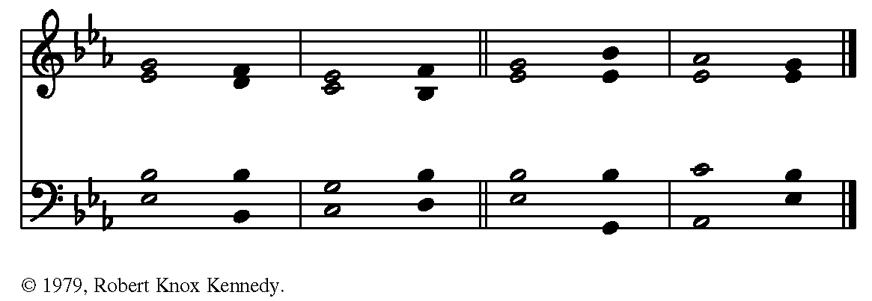

1 Answer me when I call, O God, defender of my cause; *
you set me free when I am hard-pressed;
have mercy on me and hear my prayer.
2 “You mortals, how long will you dishonor my glory; *
how long will you worship dumb idols and run after false gods?”

3 Know that God does wonders for the faithful; *
when I call, God will hear me.
4 Tremble, then, and do not sin; *
speak to your heart in silence upon your bed.

5 Offer the appointed sacrifices, *
and put your trust in the Most High.
6 Many are saying, “Oh, that we might see better times!” *
Lift up the light of your countenance upon us, O God.

7 You have put gladness in my heart, *
more than when grain and wine and oil increase.
8 I lie down in peace; at once I fall asleep; *
for only you, God, make me dwell in safety.

Second Reading 1 John 3:1-7

Reader A reading from the First Letter of John.

See what love the Father has given us, that we should be called children of God; and that is what we are. The reason the world does not know us is that it did not know him. Beloved, we are God's children now; what we will be has not yet been revealed. What we do know is this: when he is revealed, we will be like him, for we will see him as he is. And all who have this hope in him purify themselves, just as he is pure. Everyone who commits sin is guilty of lawlessness; sin is lawlessness. You know that he was revealed to take away sins, and in him there is no sin. No one who abides in him sins; no one who sins has either seen him or known him. Little children, let no one deceive you. Everyone who does what is right is righteous, just as he is righteous.

Reader The Word of the Lord.
People Thanks be to God.

Sequence Hymn This joyful Eastertide H-192

1. This joyful Eastertide,
away with care and sorrow!
My Love, the Crucified,
hath sprung to life this morrow.

Had Christ, that once was slain,
ne'er burst his three-day prison,
our faith had been in vain;
but now is Christ arisen,
arisen, arisen, arisen.

2. Death's flood hath lost its chill,
since Jesus crossed the river:
Lord of all life, from ill
my passing soul deliver. Refrain

3. My flesh in hope shall rest,
and for a season slumber,
till trump from east to west
shall wake the dead in number. Refrain

The Gospel Luke 24:36b-48

Minister The Holy Gospel of our Lord Jesus Christ according to Luke.
People Glory to you, Lord Christ.

Jesus himself stood among the disciples and said to them, “Peace be with you.” They were startled and terrified, and thought that they were seeing a ghost. He said to them, “Why are you frightened, and why do doubts arise in your hearts? Look at my hands and my feet; see that it is I myself. Touch me and see; for a ghost does not have flesh and bones as you see that I have.” And when he had said this, he showed them his hands and his feet. While in their joy they were disbelieving and still wondering, he said to them, “Have you anything here to eat?” They gave him a piece of broiled fish, and he took it and ate in their presence. Then he said to them, “These are my words that I spoke to you while I was still with you—that everything written about me in the law of Moses, the prophets, and the psalms must be fulfilled.” Then he opened their minds to understand the scriptures, and he said to them, “Thus it is written, that the Messiah is to suffer and to rise from the dead on the third day, and that repentance and forgiveness of sins is to be proclaimed in his name to all nations, beginning from Jerusalem. You are witnesses of these things.

Minister The Gospel of the Lord.
People Praise to you, Lord Christ.

Sermon The Rt. Rev. Robert Ihloff
After the sermon, silence may be kept.

Presentation and Examination of the Candidates

Bishop The Candidates will now be presented.

Presenter I present Michael Thomas Fletcher and Charles Lee Gallegos for Confirmation, and I present Kathleen Evelyn Wherthey to be received into this Communion.

Bishop Do you reaffirm your renunciation of evil?
Candidates I do.

Bishop Do you renew your commitment to Jesus Christ?
Candidates I do, and with God’s grace I will follow him as my Savior and Lord.

Those on Zoom are invited to unmute in order to pledge their support for those being confirmed and received.

Bishop Will you who witness these vows do all in your power to support these persons in their life Christ?
People We will.

Please return to mute if you have unmuted.

Bishop Let us join with those who are committing themselves to Christ
and renew our own baptismal covenant.
The Baptismal Covenant

Bishop Do you believe in God the Father?
People I believe in God, the Father almighty,
creator of heaven and earth.

Bishop Do you believe in Jesus Christ, the Son of God?
People I believe in Jesus Christ, his only Son, our Lord.
He was conceived by the power of the Holy Spirit
and born of the Virgin Mary.
He suffered under Pontius Pilate,
was crucified, died, and was buried.
He descended to the dead.
On the third day he rose again.
He ascended into heaven,
and is seated at the right hand of the Father.
He will come again to judge the living and the dead.

Bishop Do you believe in God the Holy Spirit?
People I believe in the Holy Spirit,
the holy catholic Church,
the communion of saints,
the forgiveness of sins,
the resurrection of the body,
and the life everlasting.

Bishop Will you continue in the apostles’ teaching and fellowship, in the breaking of bread, and in the prayers?
People I will, with God’s help.

Bishop Will you persevere in resisting evil, and, whenever you fall into sin, repent and return to the Lord?
People I will, with God’s help.

Bishop Will you proclaim by word and example the Good News of God in Christ?
People I will, with God’s help.

Bishop Will you seek and serve Christ in all persons, loving your neighbor as yourself?
People I will, with God’s help.

Bishop Will you strive for justice and peace among all people, and respect the dignity of every human being?
People I will, with God’s help.

Prayers for the Candidates

The Bishop then says to the congregation

Let us now pray for these persons, who have renewed their commitment to Christ.

Minister Deliver them, O Lord, from the way of sin and death.
People Lord, hear our prayer.

Minister Open their hearts to your grace and truth.
People Lord, hear our prayer.

Minister Fill them with your holy and life-giving Spirit.
People Lord, hear our prayer.

Minister Keep them in the faith and communion of your holy Church.
People Lord, hear our prayer.

Minister Teach them to love others in the power of the Spirit.
People Lord, hear our prayer.

Minister Send them into the world in witness to your love.
People Lord, hear our prayer.

Minister Bring them to the fullness of your peace and glory.
People Lord, hear our prayer.

A period of silence follows. Then the Bishop says

Almighty God, we thank you that by the death and resurrection of your Son Jesus Christ you have overcome sin and brought us to yourself, and that by the sealing of your Holy Spirit you have bound us to your service. Renew in these your servants the covenant you made with them at their Baptism. Send them forth in the power of that Spirit to perform the service you set before them; through Jesus Christ your Son our Lord, who lives and reigns with you and the Holy Spirit, one God, now and for ever.
People Amen.

The Bishop lays hands upon each candidate for confirmation and says

Defend, O Lord, your servant N. with your heavenly grace, that he may continue yours for ever, and daily increase in your Holy Spirit more and more, until he comes to your everlasting kingdom.
People Amen.

The Bishop takes the hand of the candidate for reception and says

N., we recognize you as a member of the one holy catholic and apostolic Church, and we receive you into the fellowship of this Communion. God, the Father, Son, and Holy Spirit, bless, preserve, and keep you.
People Amen.

The Bishop concludes with this prayer

Almighty and everliving God, let your fatherly hand ever be over these your servants; let your Holy Spirit ever be with them; and so lead them in the knowledge and obedience of your Word, that they may serve you in this life, and dwell with you in the life to come; through Jesus Christ our Lord.
People Amen.

The Peace

Bishop La paz del Señor sea siempre con ustedes.
The peace of the Lord be always with you
People And also with you. or Y con tu espíritu.

Parish Notices

The Holy Communion

Offertory Sentence

Bishop Let us with gladness present the offerings and oblations of our life and labor to the Lord.

Offertory Anthem Hallelujah! Salvation and Glory (arr. Khannanov)

Doxology Praise God, from whom all blessings flow H-380 V3

Praise God, from whom all blessings flow;
Praise Him, all creatures here below;
Praise Him above, ye heav'nly host;
Praise Father, Son, and Holy Ghost. Amen.

The Great Thanksgiving Eucharistic Prayer A*, BCP pg. 361

Bishop The Lord be with you.
People And also with you.
Bishop Lift up your hearts.
People We lift them to the Lord.
Bishop Let us give thanks to the Lord our God.
People It is right to give God thanks and praise.

Bishop It is right, and a good and joyful thing, always and everywhere to give thanks to you, Almighty God, Creator of heaven and earth, but chiefly are we bound to praise you for the glorious resurrection of your Son Jesus Christ our Lord; for he is the true Paschal Lamb, who was sacrificed for us, and has taken away the sin of the world. By his death he has destroyed death, and by his rising to life again he has won for us everlasting life.

Therefore we praise you, joining our voices with Angels and Archangels and with all the company of heaven, who for ever sing this hymn to proclaim the glory of your Name:

Sanctus S-125
+
+
+
Setting: From A Community Mass; Richard Proulx (b. 1937)

Bishop Holy and gracious God: In your infinite love you made us for yourself; and, when we had fallen into sin and become subject to evil and death, you, in your mercy, sent Jesus Christ, your only and eternal Son, to share our human nature, to live and die as one of us, to reconcile us to you, the God and maker of all. Jesus stretched out his arms upon the cross, and offered himself in obedience to your will, a perfect sacrifice for the whole world.

On the night he was handed over to suffering and death, our Savior Jesus Christ took bread; and when he had given thanks to you, he broke it, and gave it to his disciples, and said, “Take, eat: This is my Body, which is given for you. Do this for the remembrance of me.” +

After supper Jesus took the cup of wine; and when he had given thanks, he gave it to them, and said, “Drink this, all of you: This is my Blood of the new Covenant, which is shed for you and for many for the forgiveness of sins. Whenever you drink it, do this for the remembrance of me.” +

Therefore we proclaim the mystery of faith:

Bishop and People

Christ has died.
Christ is risen.
Christ will come again.

We celebrate the memorial of our redemption, Almighty God, in this sacrifice of praise and thanksgiving. Recalling Christ’s death, resurrection, and ascension, we offer you these gifts. Sanctify them by your Holy Spirit to be for your people the Body and Blood of your Son, the holy food and drink of new and unending life in Christ.

Sanctify us also that we may faithfully receive this holy Sacrament, and serve you in unity, constancy, and peace; and at the last day bring us with all your saints into the joy of your eternal kingdom.

All this we ask through Jesus Christ our Savior. By Christ, and with Christ, and in Christ, in the unity of the Holy Spirit all honor and glory is yours, Almighty God, now and for ever.

People AMEN.

The Lord's Prayer (Traditional)

Bishop And now, as our Savior Christ has taught us, we are bold to say,

People Our Father, who art in heaven, hallowed be thy Name, thy kingdom come, thy will be done, on earth as it is in heaven. Give us this day our daily bread. And forgive us our trespasses, as we forgive those who trespass against us. And lead us not into temptation, but deliver us from evil. For thine is the kingdom, and the power, and the glory, for ever and ever. Amen.

The Breaking of the Bread

The Bishop breaks the consecrated bread. A period of silence is kept.

Fraction Anthem S-171

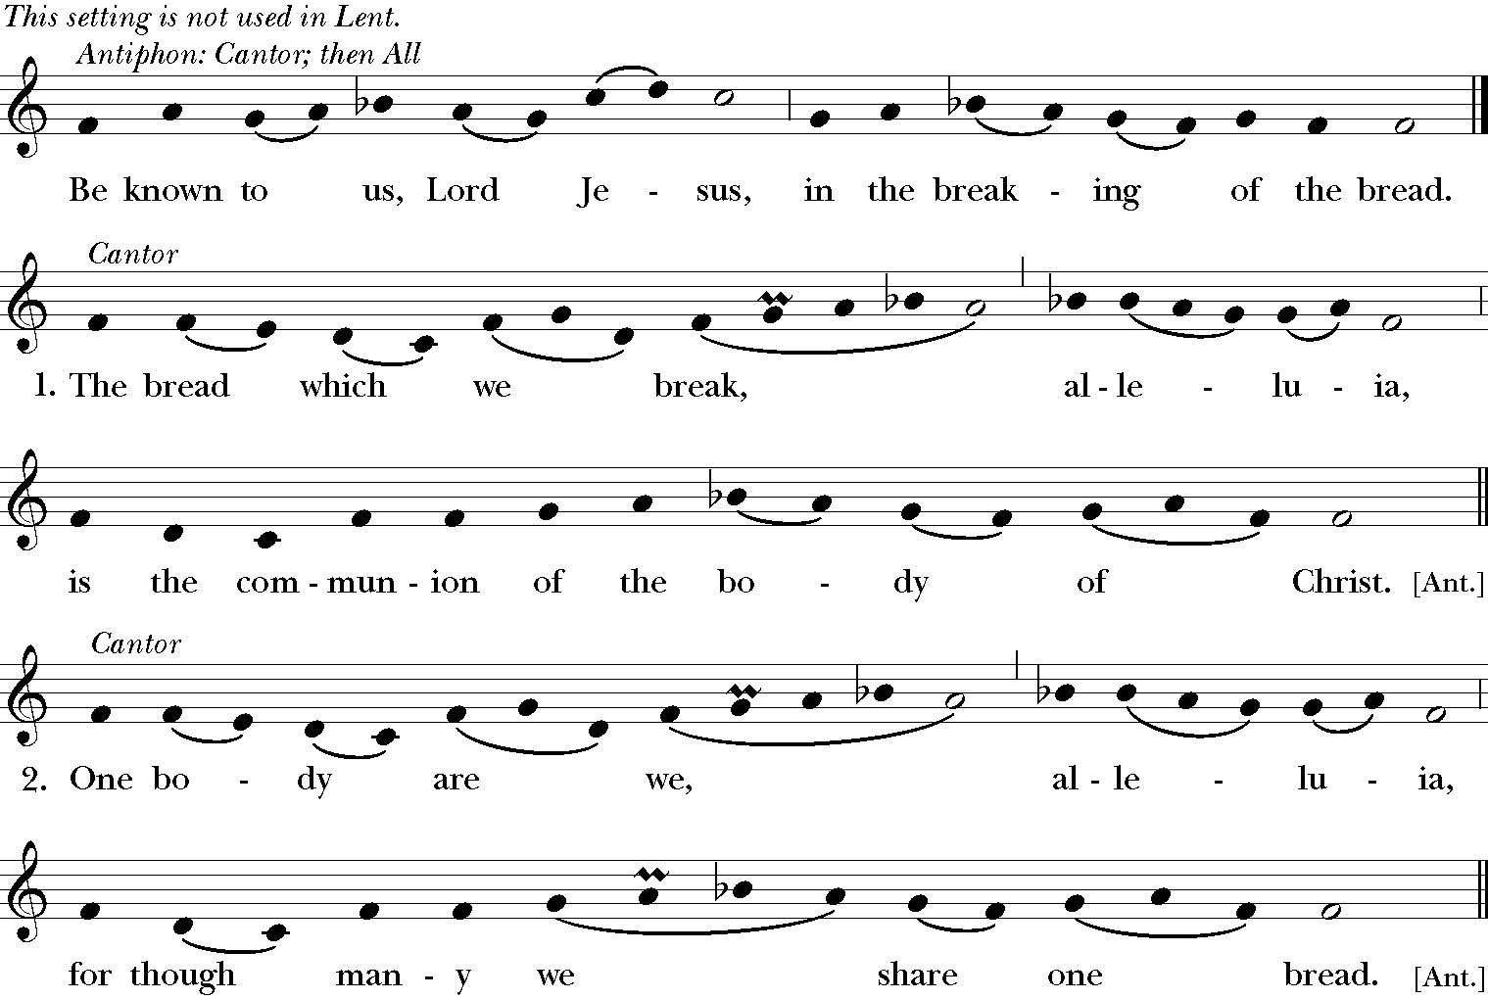

Mode 6 Melody; adapt. Mason Martens (1933-1991)

A Prayer for Spiritual Communion

People In union, O Lord, with your faithful people at every altar of your Church, where the Holy Eucharist is now being celebrated, we desire to offer to you praise and thanksgiving. We remember your death, Lord Christ; we proclaim your resurrection; we await your coming in glory. And since we cannot receive you today in the Sacrament of your Body and Blood, we beseech you to come spiritually into our hearts. Cleanse and strengthen us with your grace, Lord Jesus, and let us never be separated from you. May we live in you, and you in us, in this life and in the life to come. Amen.

Communion Hymn Come, risen Lord, and deign to be our guest H-305

1. Come, risen Lord, and deign to be our guest;
nay, let us be thy guests; the feast is thine;
thyself at thine own board make manifest
in thine own Sacrament of Bread and Wine.
2. We meet, as in the upper room they met;
thou at the table, blessing, yet dost stand:
'This is my body'; so thou givest yet:
faith still receives the cup as from thy hand.
3. One body we, one Body who partake,
one Church united in communion blest;
one Name we bear, one Bread of life we break,
with all thy saints on earth and saints at rest.
4. One with each other, Lord, for one in thee,
who are one Savior and one living Head;
then open thou our eyes, that we may see;
be known to us in breaking of the Bread.

Post-Communion Prayer EOW pg. 69

Bishop Let us pray.
People God of abundance, you have fed us with the bread of life and cup of salvation; you have united us with Christ and one another; and you have made us one with all your people in heaven and on earth. Now send us forth in the power of your Spirit, that we may proclaim your redeeming love to the world and continue for ever in the risen life of Christ our Savior. Amen.

Blessing

The Bishop blesses the people.

Closing Hymn There’s a Sweet, Sweet Spirit L-120

1. There's a sweet, sweet Spirit in this place,
And I know that it's the Spirit of the Lord;
There are sweet expressions on each face,
And I know they feel the presence of the Lord.

Sweet Holy Spirit, Sweet heavenly Dove,
Stay right here with us, filling us with Your love.
And for these blessings we lift our hearts in praise;
Without a doubt we'll know that we have been revived,
When we shall leave this place.

2. There are blessings you cannot receive
Till you know Him in His fullness and believe;
You're the one to profit when you say,
"I am going to walk with Jesus all the way." Refrain

3. If you say He saved you from your sin,
Now you're weak, you're bound and cannot enter in,
You can make it right if you will yield,
You'll enjoy the Holy Spirit that we feel. Refrain

Dismissal

Minister ¡Aleluya, aleluya! Salgamos en nombre de Cristo.
Let us go forth in the name of Christ.
People Thanks be to God. Alleluia, Alleluia!
or Demos gracias a Dios. ¡Aleluya, aleluya!

Postlude Dr. Ildar Khannanov

The texts in this service are from The Book of Common Prayer 1979 (BCP), Enriching our Worship (EOW), and El Libro de Oración Común. Hymns and service music are from The Hymnal 1982 and Lift Every Voice and Sing II. Used by permission. OneLicense.net #A-722440.

*This service makes use of an alternative form of Eucharistic Prayer A, as approved for trial use by General Convention in Resolution 2018-D078.

