The Third Sunday
after the Epiphany

January 24, 2021

10:00 am

1101 Bay Ridge Avenue
Annapolis, Maryland 21403
www.stlukeseastport.org

Liturgy of the Word

Prelude

Opening Hymn Jesus calls us; o’er the tumult H-550

1. Jesus calls us; o'er the tumult
of our life's wild, restless sea,
day by day his clear voice soundeth,
saying, "Christian, follow me;"
saying, "Christian, follow me;"
2. As, of old, Saint Andrew heart it
by the Galilean lake,
turned from home and toil and kindred,
leaving all for his dear sake.
leaving all for his dear sake.
3. Jesus calls us from the worship
of the vain world's golden store;
from each idol that would keep us,
saying, "Christian, love me more."
saying, "Christian, love me more."
4. In our joys and in our sorrows,
days of toil and hours of ease,
still he calls, in cares and pleasures,
"Christian, love me more than these."
"Christian, love me more than these."
5. Jesus calls us! By thy mercies,
Savior, may we hear thy call,
give our hearts to thine obedience,
serve and love thee best of all.
serve and love thee best of all.

Priest Blessed be God: Father, Son and Holy Spirit.
People And blessed be God’s kingdom, now and forever. Amen.

Priest Almighty God, to you all hearts are open, all desires known, and from you no secrets are hid: Cleanse the thoughts of our hearts by the inspiration of your Holy Spirit, that we may perfectly love you, and worthily magnify your holy Name; through Christ our Lord.
People Amen.
Gloria S-280
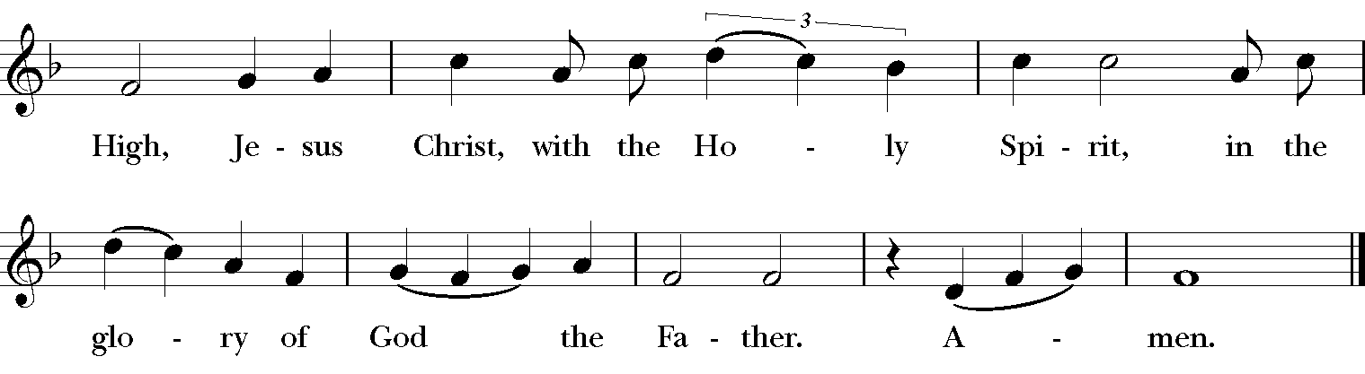

Setting: Robert Powell (b. 1932)

The Collect of the Day

Priest The Lord be with you.
People And also with you.

Priest Let us pray.
Give us grace, O Lord, to answer readily the call of our Savior Jesus Christ and proclaim to all people the Good News of his salvation, that we and the whole world may perceive the glory of his marvelous works; who lives and reigns with you and the Holy Spirit, one God, for ever and ever.
People Amen.

First Reading Jonah 3:1-5,10

Reader A Reading from the Book of Jonah.

The word of the Lord came to Jonah a second time, saying, “Get up, go to Nineveh, that great city, and proclaim to it the message that I tell you.” So Jonah set out and went to Nineveh, according to the word of the Lord. Now Nineveh was an exceedingly large city, a three days' walk across. Jonah began to go into the city, going a day's walk. And he cried out, “Forty days more, and Nineveh shall be overthrown!” And the people of Nineveh believed God; they proclaimed a fast, and everyone, great and small, put on sackcloth. When God saw what they did, how they turned from their evil ways, God changed his mind about the calamity that he had said he would bring upon them; and he did not do it.
Reader The Word of the Lord.
People Thanks be to God.

Psalm 62:6-14 St. Helena Breviary

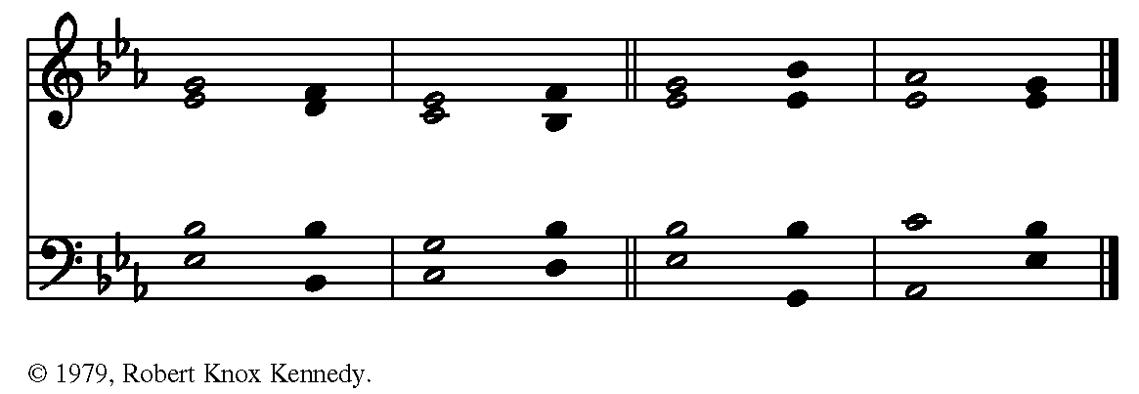

6 For God alone my soul in silence waits; *
truly, there is my hope.
7 God alone is my rock and my salvation, *
my stronghold, so that I shall not be shaken.

8 In God is my safety and my honor; *
God is my strong rock and my refuge.
9 Put your trust in God always, O people; *
pour out your hearts before the One who is our refuge.

10 Those of high degree are but a fleeting breath, *
even those of low estate cannot be trusted.
11 On the scales they are lighter than a breath, *
all of them together.

12 Put no trust in extortion; in robbery take no empty pride; *
though wealth increase, set not your heart upon it.
13 God has spoken once, twice have I heard it, *
that power belongs to God.

**14 Steadfast love is yours, O God, *
for you repay everyone according to their deeds.

Second Reading Corinthians 7:29-31
Reader A reading from the First Letter to the Corinthians.

I mean, brothers and sisters, the appointed time has grown short; from now on, let even those who have wives be as though they had none, and those who mourn as though they were not mourning, and those who rejoice as though they were not rejoicing, and those who buy as though they had no possessions, and those who deal with the world as though they had no dealings with it. For the present form of this world is passing away.

Reader The Word of the Lord.
People Thanks be to God.

Sequence Hymn Christ, Be Our Light (Bernadette Farrell)

1. Longing for light, we wait in darkness.
Longing for truth, we turn to you.
Make us your own, your holy people,
light for the world to see.

Christ, be our light! Shine in our hearts.
Shine through the darkness. Christ, be our light!
Shine in your Church gathered today.

2. Longing for peace, our world is troubled
Longing for hope, many despair.
Your word alone has pow'r to save us.
Make us your living voice. Refrain

3. Longing for food, many are hungry.
Longing for water, many still thirst.
Make us Your bread, broken for others,
shared until all are fed. Refrain

4. Longing for shelter, many are homeless.
Longing for warmth, many are cold.
Make us Your building, sheltering others,
walls made of living stone. Refrain
5. Many the gifts, many the people,
many the hearts that yearn to belong.
Let us be servants to one another,
making your kingdom come. Refrain

The Gospel Mark 1:14-20

Priest The Holy Gospel of our Lord Jesus Christ according to Mark.
People Glory to you, Lord Christ.

After John was arrested, Jesus came to Galilee, proclaiming the good news of God, and saying, “The time is fulfilled, and the kingdom of God has come near; repent, and believe in the good news.” As Jesus passed along the Sea of Galilee, he saw Simon and his brother Andrew casting a net into the sea—for they were fishermen. And Jesus said to them, “Follow me and I will make you fish for people.” And immediately they left their nets and followed him. As he went a little farther, he saw James son of Zebedee and his brother John, who were in their boat mending the nets. Immediately he called them; and they left their father Zebedee in the boat with the hired men, and followed him.

Priest The Gospel of the Lord.
People Praise to you, Lord Christ.

Sermon

After the sermon, silence may be kept.

The Nicene Creed A New Zealand Prayer Book, pg. 410

We believe in one God, the Father, the Almighty, maker of heaven and earth, of all that is, seen and unseen. We believe in one Lord, Jesus Christ, the only Son of God, eternally begotten of the Father, God from God, Light from Light, true God from true God, begotten, not made, of one Being with the Father; through him all things were made. For us and for our salvation he came down from heaven: was incarnate of the Holy Spirit and the Virgin Mary and became fully human. For our sake he was crucified under Pontius Pilate; he suffered death and was buried. On the third day he rose again in accordance with the Scriptures; he ascended into heaven and is seated at the right hand of the Father. He will come again in glory to judge the living and the dead, and his kingdom will have no end. We believe in the Holy Spirit, the Lord, the giver of life, who proceeds from the Father and the Son, who in unity with the Father and the Son is worshiped and glorified, and has spoken through the Prophets. We believe in one holy catholic and apostolic Church. We acknowledge one baptism for the forgiveness of sins. We look for the resurrection of the dead, and the life of the world to come. Amen.

The Prayers of the People Form IV, BCP pg. 388

Leader Let us pray for the Church and for the world.

Grant, Almighty God, that all who confess your Name may be united in your truth, live together in your love, and reveal your glory in the world.

In the Anglican Communion, we pray for ___________________.
In the Diocese of Maryland, we pray for____________________.

Silence

Leader God, in your mercy
People Hear our prayer.

Leader Guide the people of this land, and of all the nations, in the ways of justice and peace; that we may honor one another and serve the common good.

Silence

Leader God, in your mercy
People Hear our prayer.

Leader Give us all a reverence for the earth as your own creation, that we may use its resources rightly in the service of others and to your honor and glory.

Silence

Leader God, in your mercy
People Hear our prayer.

Leader Bless all whose lives are closely linked with ours, and grant that we may serve Christ in them, and love one another as he loves us.

Silence

Leader God, in your mercy
People Hear our prayer.

Leader Comfort and heal all those who suffer in body, mind, or spirit; give them courage and hope in their troubles, and bring them the joy of your salvation.

We pray for those on our parish prayer list, especially ________________, and for those we name aloud or in our hearts.

Silence

Leader God, in your mercy
People Hear our prayer.

Leader We commend to your mercy all who have died, [especially _____________], that your will for them may be fulfilled; and we pray that we may share with all your saints in your eternal kingdom.

Silence

Leader God, in your mercy
People Hear our prayer.

Priest Almighty God, we have become stewards of this good land: We humbly beseech thee that we may always prove ourselves a people mindful of thy favor and glad to do thy will. Bless our land with honorable industry, sound learning, and pure manners. Save us from violence, discord, and confusion; from pride and arrogance, and from every evil way. Defend our liberties, and fashion into one united people the multitudes brought hither out of many kindreds and tongues. Endue with the spirit of wisdom those to whom in thy Name we entrust the authority of government, that there may be justice and peace at home, and that, through obedience to thy law, we may show forth thy praise among the nations of the earth. In the time of prosperity, fill our hearts with thankfulness, and in the day of trouble, suffer not our trust in thee to fail; all which we ask through Jesus Christ our Lord.
People Amen.

The Confession

Priest Let us confess our sins against God and our neighbor.

People Most merciful God, we confess that we have sinned against you in thought, word, and deed, by what we have done, and by what we have left undone. We have not loved you with our whole heart; we have not loved our neighbors as ourselves. We are truly sorry and we humbly repent. For the sake of your Son Jesus Christ, have mercy on us and forgive us; that we may delight in your will, and walk in your ways, to the glory of your Name. Amen.

Priest Almighty God have mercy on you, forgive you all your sins through the grace of Jesus Christ, strengthen you in all goodness, and by the power of the Holy Spirit keep you in eternal life. Amen.

The Peace

Priest La paz del Señor sea siempre con ustedes.
The peace of the Lord be always with you
People And also with you. or Y con tu espíritu.
Parish Notices

The Holy Communion
Offertory Sentence

Priest Walk in love, as Christ loved us and gave himself for us, an offering and sacrifice to God. Ephesians 5:2

Offertory Anthem Lakeshore (Cesáreo Gabarain)

Doxology Praise God, from whom all blessings flow H-380 V3

Praise God, from whom all blessings flow;
Praise Him, all creatures here below;
Praise Him above, ye heav'nly host;
Praise Father, Son, and Holy Ghost. Amen.

The Great Thanksgiving Eucharistic Prayer A*, BCP pg. 361

Priest The Lord be with you.
People And also with you.
Priest Lift up your hearts.
People We lift them to the Lord.
Priest Let us give thanks to the Lord our God.
People It is right to give God thanks and praise.

Priest It is right, and a good and joyful thing, always and everywhere to give thanks to you, Almighty God, Creator of heaven and earth, because in the mystery of the Word made flesh, you have caused a new light to shine in our hearts, to give the knowledge of your glory in the face of your Son Jesus Christ our Savior.

Therefore we praise you, joining our voices with Angels and Archangels and with all the company of heaven, who for ever sing this hymn to proclaim the glory of your Name:

Sanctus S-129
+
+
+
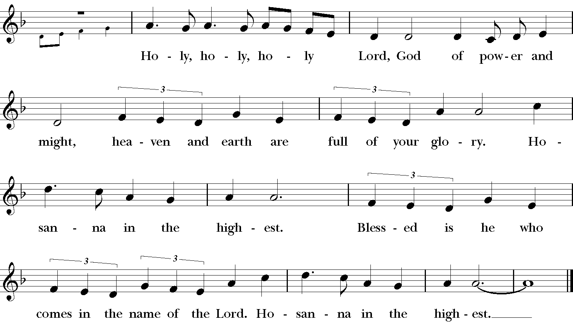
Setting: Robert Powell (b. 1932)

Priest Holy and gracious God: In your infinite love you made us for yourself; and, when we had fallen into sin and become subject to evil and death, you, in your mercy, sent Jesus Christ, your only and eternal Son, to share our human nature, to live and die as one of us, to reconcile us to you, the God and maker of all. Jesus stretched out his arms upon the cross, and offered himself in obedience to your will, a perfect sacrifice for the whole world.

On the night he was handed over to suffering and death, our Savior Jesus Christ took bread; and when he had given thanks to you, he broke it, and gave it to his disciples, and said, “Take, eat: This is my Body, which is given for you. Do this for the remembrance of me.” +

After supper Jesus took the cup of wine; and when he had given thanks, he gave it to them, and said, “Drink this, all of you: This is my Blood of the new Covenant, which is shed for you and for many for the forgiveness of sins. Whenever you drink it, do this for the remembrance of me.” +

Therefore we proclaim the mystery of faith:

Priest and People

Christ has died.
Christ is risen.
Christ will come again.

We celebrate the memorial of our redemption, Almighty God, in this sacrifice of praise and thanksgiving. Recalling Christ’s death, resurrection, and ascension, we offer you these gifts. Sanctify them by your Holy Spirit to be for your people the Body and Blood of your Son, the holy food and drink of new and unending life in Christ.

Sanctify us also that we may faithfully receive this holy Sacrament, and serve you in unity, constancy, and peace; and at the last day bring us with all your saints into the joy of your eternal kingdom.

All this we ask through Jesus Christ our Savior. By Christ, and with Christ, and in Christ, in the unity of the Holy Spirit all honor and glory is yours, Almighty God, now and for ever.

People AMEN.

The Lord's Prayer (Contemporary)

Priest As our Savior Christ has taught us, we now pray,

People Our Father in heaven, hallowed be your Name, your kingdom come, your will be done, on earth as in heaven. Give us today our daily bread. Forgive us our sins as we forgive those who sin against us. Save us from the time of trial, and deliver us from evil. For the kingdom, the power, and the glory are yours, now and for ever. Amen.

The Breaking of the Bread

The priest breaks the consecrated bread. A period of silence is kept

Fraction Anthem S-154
Setting: From New Plainsong; David Hurd (b. 1950)
A Prayer for Spiritual Communion

People In union, O Lord, with your faithful people at every altar of your Church, where the Holy Eucharist is now being celebrated, we desire to offer to you praise and thanksgiving. We remember your death, Lord Christ; we proclaim your resurrection; we await your coming in glory. And since we cannot receive you today in the Sacrament of your Body and Blood, we beseech you to come spiritually into our hearts. Cleanse and strengthen us with your grace, Lord Jesus, and let us never be separated from you. May we live in you, and you in us, in this life and in the life to come. Amen.

Post-Communion Prayer

Priest Let us pray.
People Eternal God, heavenly Father, you have graciously accepted us as living members of your Son our Savior Jesus Christ. Send us now into the world in peace, and grant us strength and courage to love and serve you with gladness and singleness of heart; through Christ our Lord. Amen.

Blessing Adapted from The Book of Occasional Services

Priest May Christ, the Son of God, be manifest in you, that your lives may be a light to the world; and the blessing of God, the Eternal Majesty, the Incarnate Word, and the Abiding Spirit, be among you, and remain with you always.
People Amen.
Closing Hymn Great is Thy Faithfulness L-189

1. Great is Thy faithfulness, O God my Father,

There is no shadow of turning with Thee;

Thou changest not, Thy compassions, they fail not,

As Thou hast been Thou forever wilt be.

Great is Thy faithfulness! Great is Thy faithfulness!

Morning by morning new mercies I see;

All I have needed Thy hand hath provided,

Great is Thy faithfulness, Lord unto me!

2. Summer and winter, and springtime and harvest,

Sun, moon and stars in their courses above,

Join with all nature in manifold witness,

To Thy great faithfulness, mercy and love. Refrain

3. Pardon for sin and a peace that endureth,

Thine own dear presence to cheer and to guide;

Strength for today and bright hope for tomorrow,

Blessings all mine, with ten thousand beside! Refrain

Dismissal

Priest Vayan en paz para amar y servir al Señor.
Go in peace to love and serve the Lord.
People Thanks be to God. or Demos gracias a Dios.

The texts in this service are from The Book of Common Prayer 1979 (BCP), Enriching our Worship (EOW), The Book of Occasional Services (BOS), and El Libro de Oración Común. Hymns and service music are from The Hymnal 1982 and Lift Every Voice and Sing II. Used by permission. OneLicense.net #A-722440.

*This service makes use of an alternative form of Eucharistic Prayer A, as approved for trial use by General Convention in Resolution 2018-D078.

